**Blog on**

**Session 2021-2022**

**SUBMITTED TO SUBMITTED BY**

**Data Trained Education Sourabh Jhod**

**Content**

1. Problem Definition.

2. Data Analysis.

3. EDA Concluding Remark.

4. Pre-Processing Pipeline.

5. Building Machine Learning Models.

6. Concluding Remarks.

**Introduction**:

Flight ticket prices can be something hard to guess, today we might see a price, check out the price of the same flight tomorrow, it will be a different story. We might have often heard travellers saying that flight ticket prices are so unpredictable. Here you will be provided with prices of flight tickets for various airlines between the months of March and June of 2019 and between various cities.

Size of training set: **10683** records

Size of test set: **2671** records

**Problem Statement**:

You have to use your skills as a data scientist and build a machine learning model to predict the price of the flight ticket.

**Independent Variables:**

* **Airline**: The name of the airline.
* **Date_of_Journey**: The date of the journey
* **Source**: The source from which the service begins.
* **Destination**: The destination where the service ends.
* **Route**: The route taken by the flight to reach the destination.
* **Dep_Time**: The time when the journey starts from the source.
* **Arrival_Time**: Time of arrival at the destination.
* **Duration**: Total duration of the flight.
* **Total_Stops**: Total stops between the source and destination.
* **Additional_Info**: Additional information about the flight

**Dependent Variable**

* **Price**: The price of the ticket

**Importing Libraries:**

First, we will import required library to import our dataset.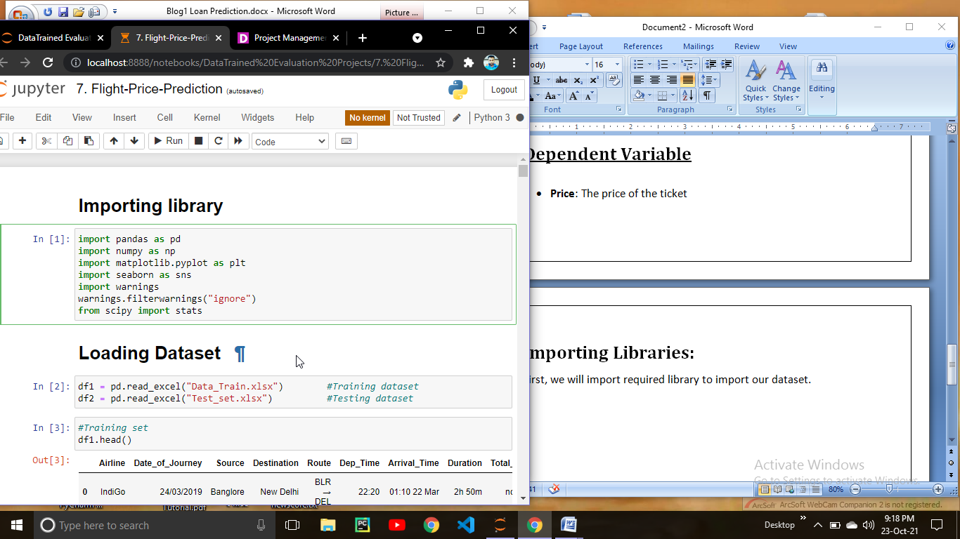

**Loading Data set**

Since our data is in two different file i.e training set and testing set so we have to import both the file.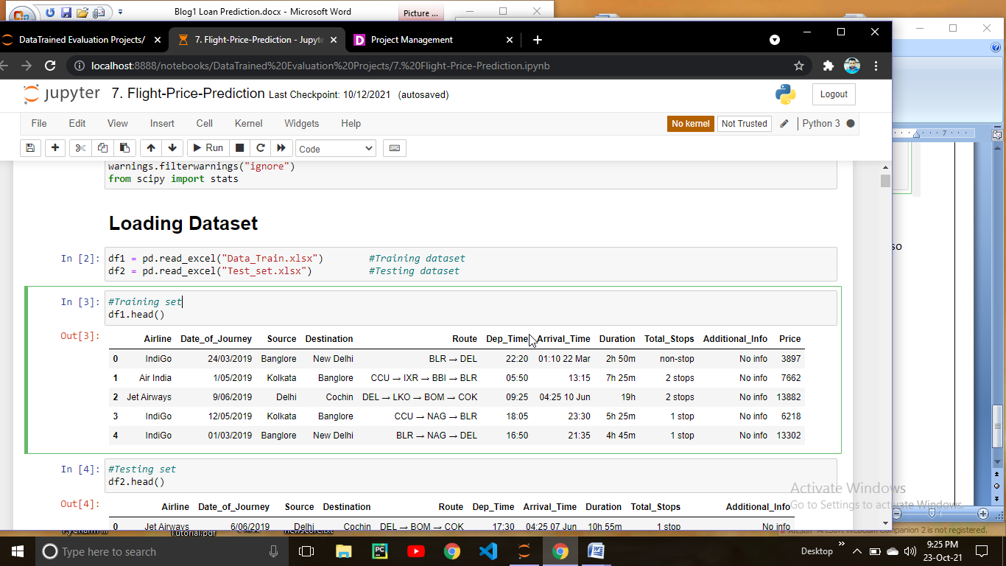

This is the way to load data frame using pandas. Since the data is in excel file we have to load the file using read excel.

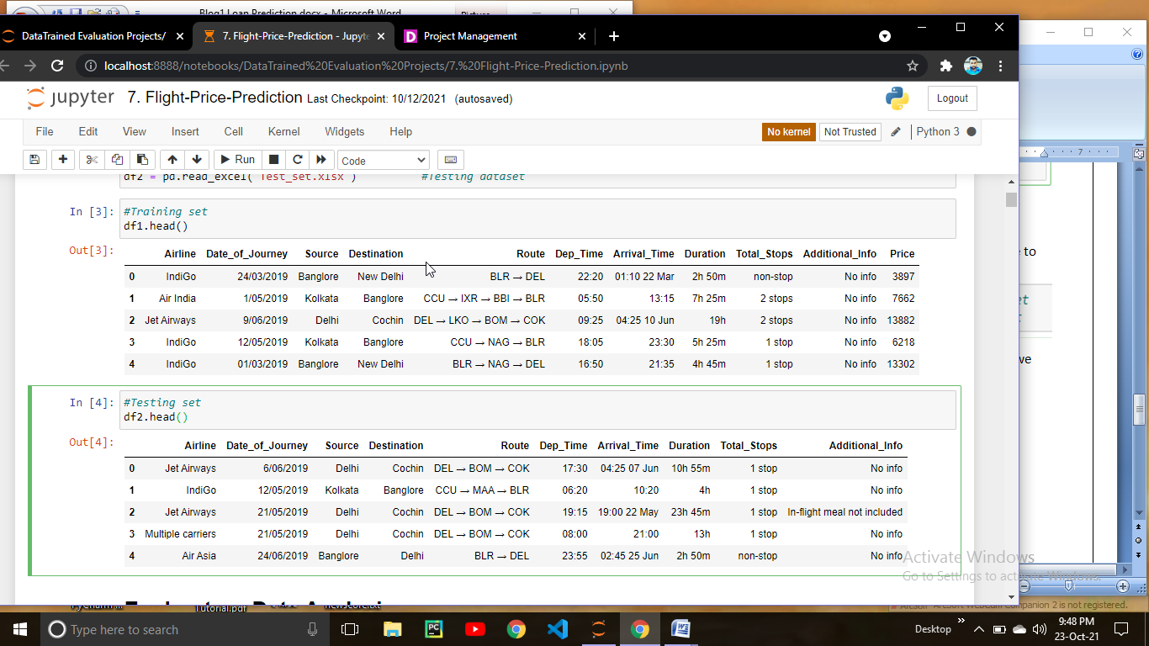

This is how our data looks like.

Lets check the size of our data

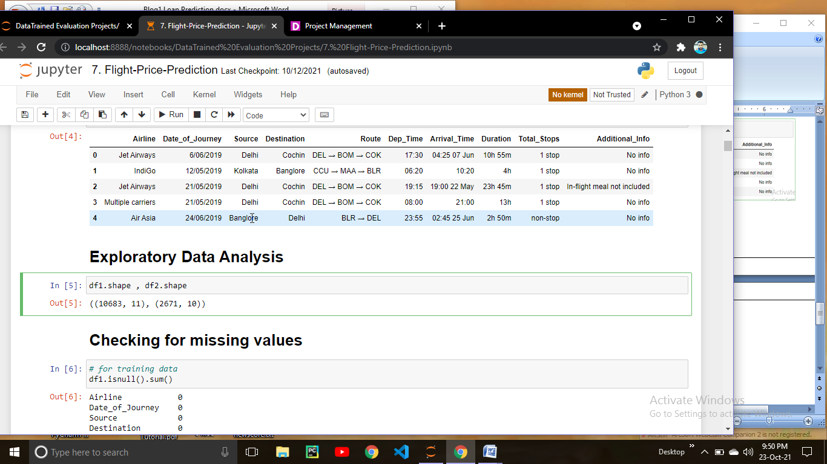

* Our training data has 10683 and 11 columns.
* Testing set has 2671 rows and 10 columns.

Since we have Training & Testing set in two different file we have to do all the preprocessing steps saperately for both the dataframe.

**Checking for missing values**

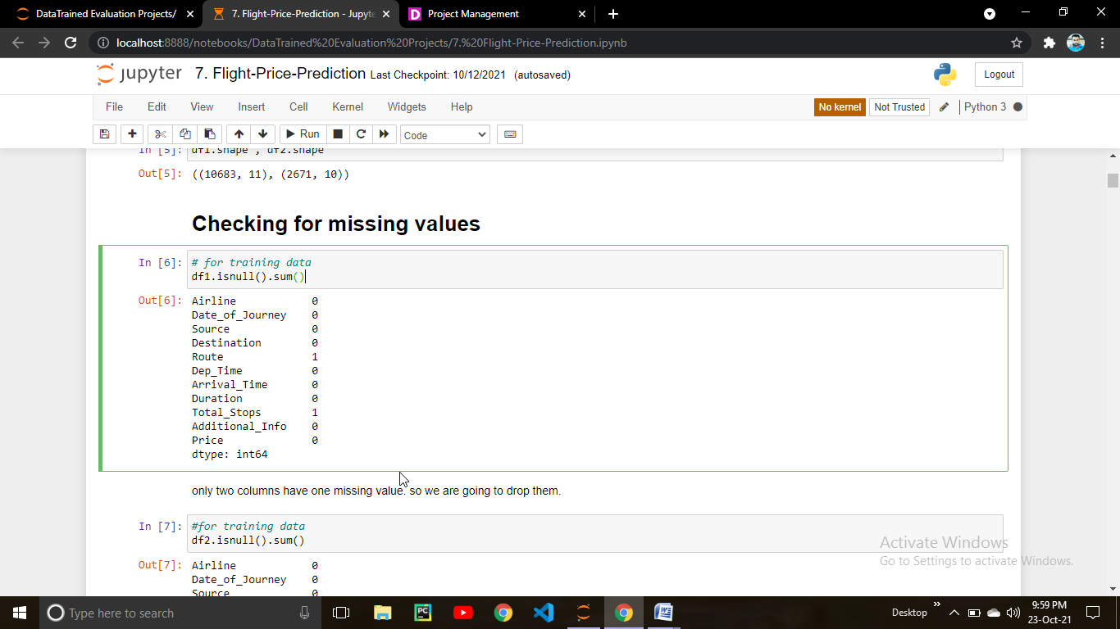

we have only one missing value in Route column.

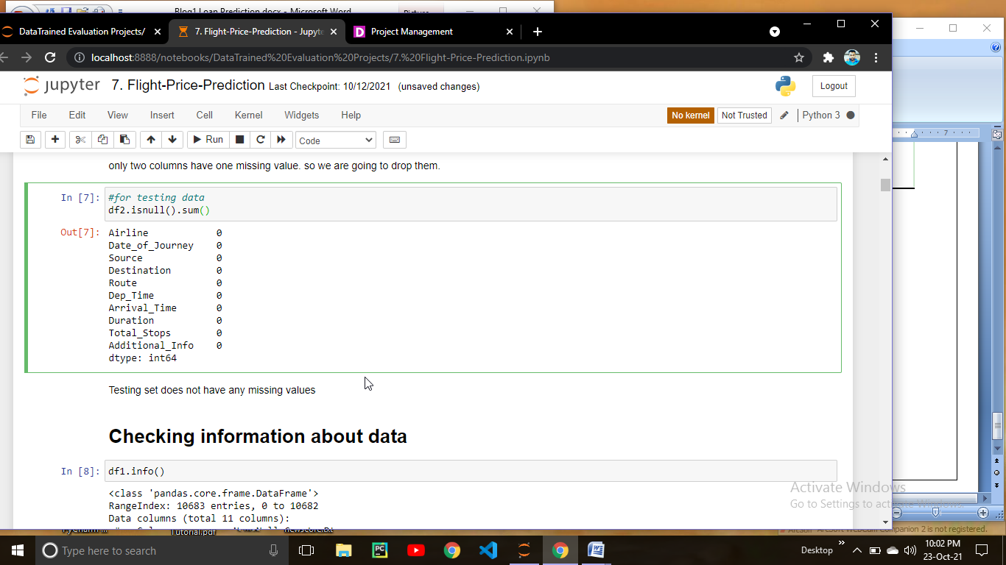

None of the values are missing in testing set

So what we can do is we can simply delete that missing rows.

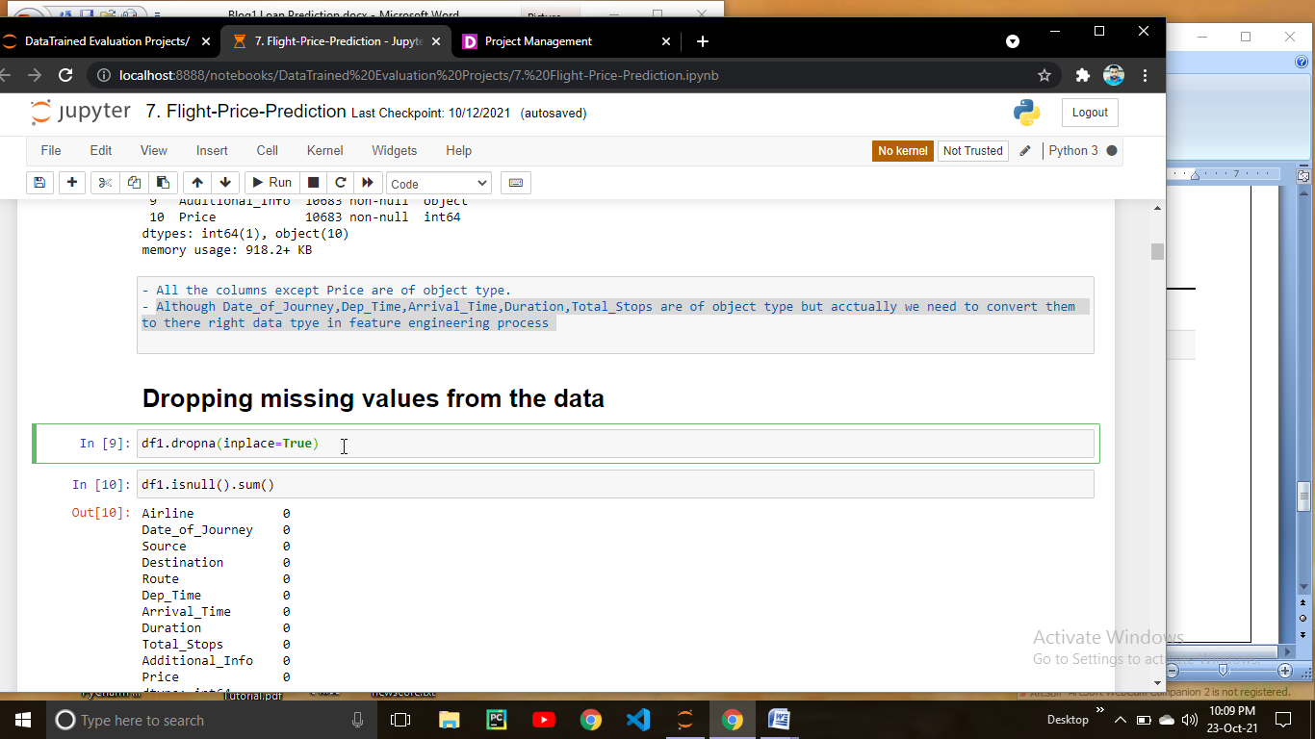

Lets check the information about the data.

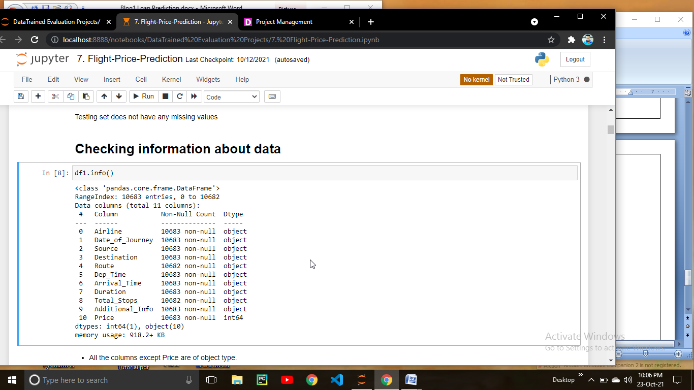

* 10 columns are of object type and 1 in of int type.
* Data contains 918.2+ kb memory.
* Although Date_of_Journey,Dep_Time,Arrival_Time,Duration,Total_Stops are of object type but actually we need to convert them to there right data tpye in feature engineering process.

Lets check for the duplicate values present in our data.

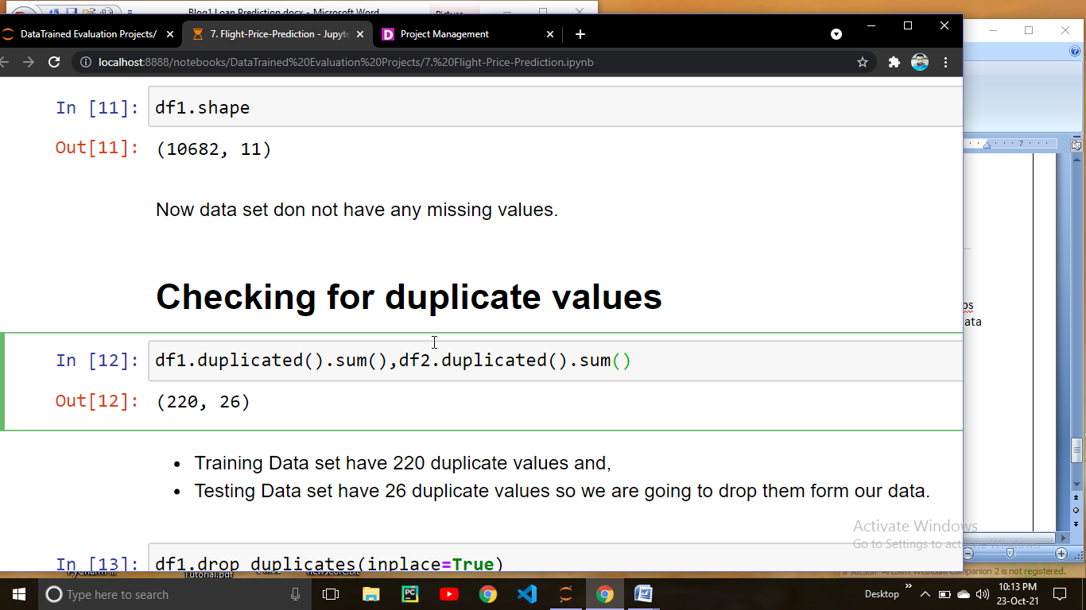

Df1 has 220 duplicate values & df2 has 26 duplicate values.

We have to remove those duplicate columns. For removing those duplicate columns.

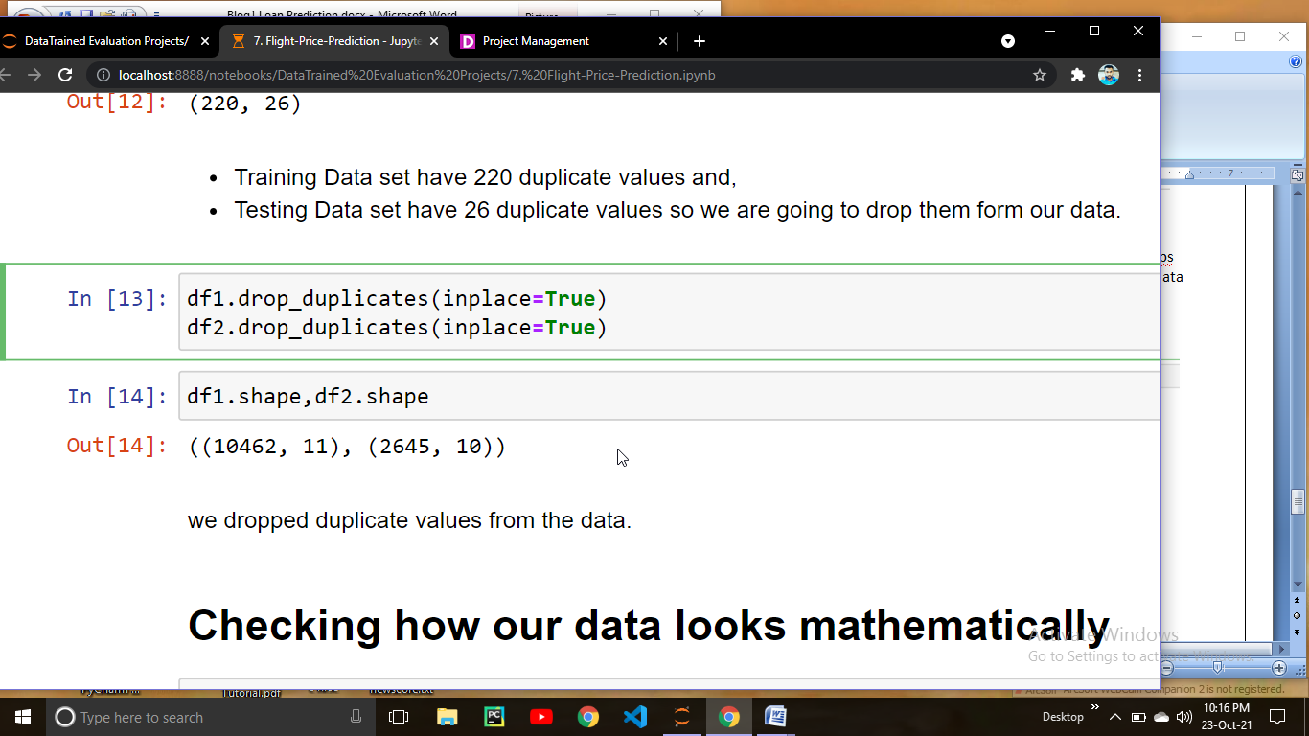

Now we can observed that we removed duplicate values and now our training data have 10462 records & testing set have 2645 records.

# Feature Engineering

# Date_of_Journey is of Object type so we are Converting Date_of_Journey column into date time index.

# 

# Now we are goint to extract Day,Month,and Year saperately from the Date_of_Journey column.

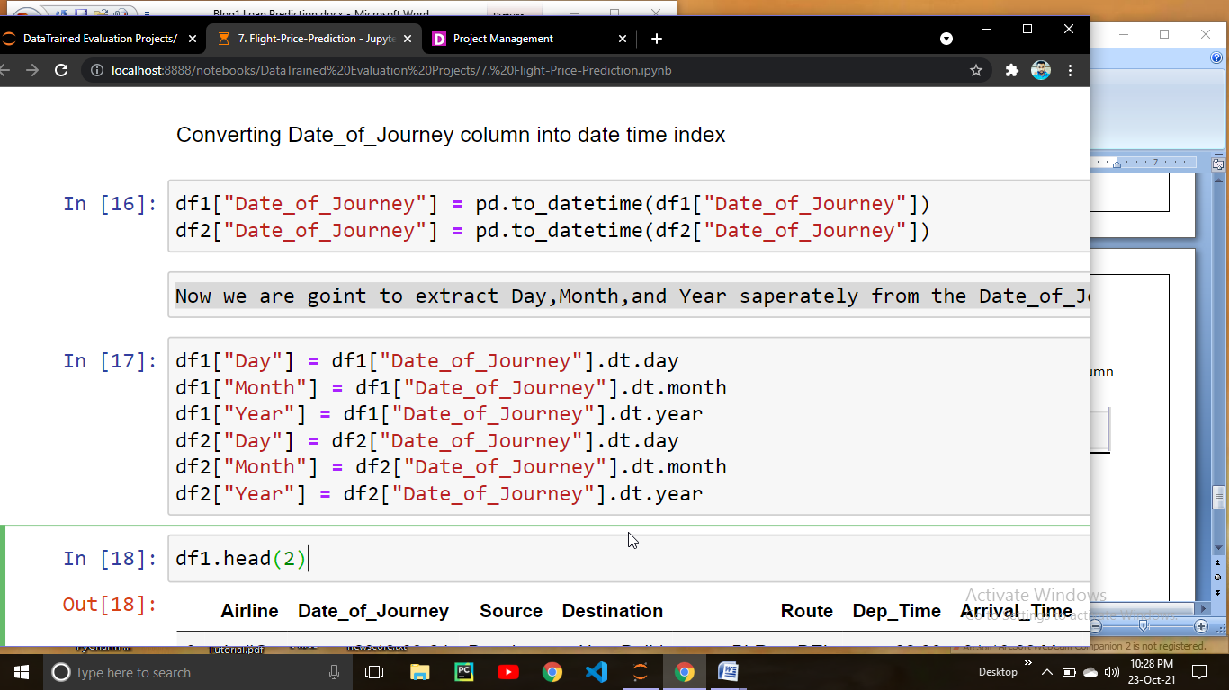

Now we can drop Date_of_Journey column

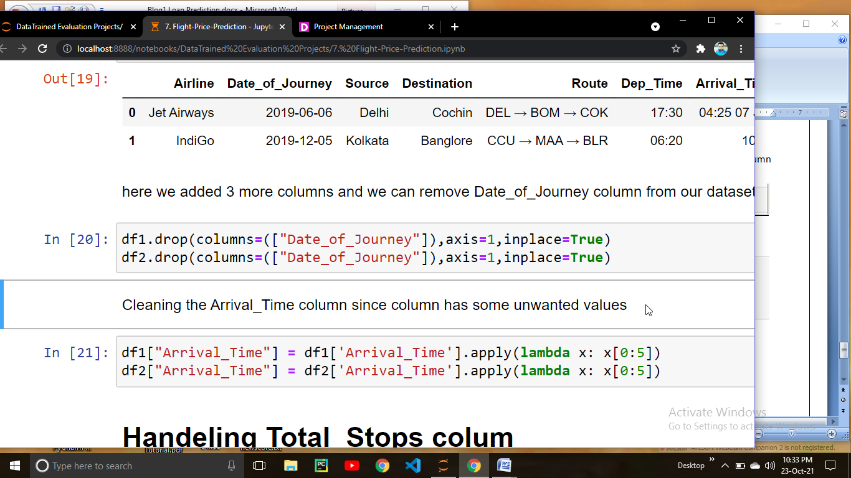

# Lets Handel Total_Stops colum

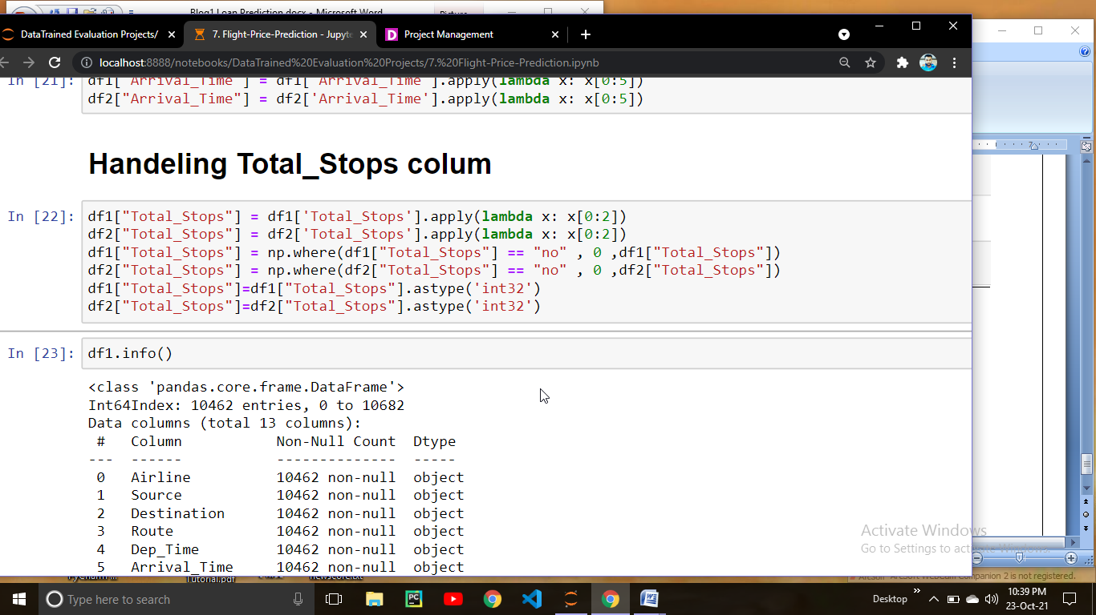

Lets convert Deep_Time & Arrival column

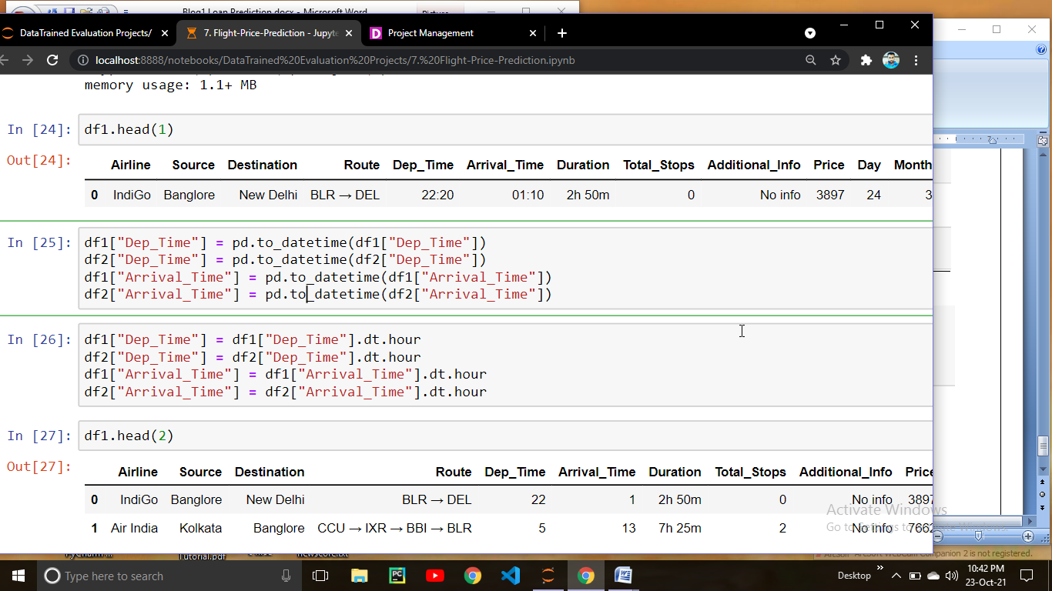

**Handling Duration Column**

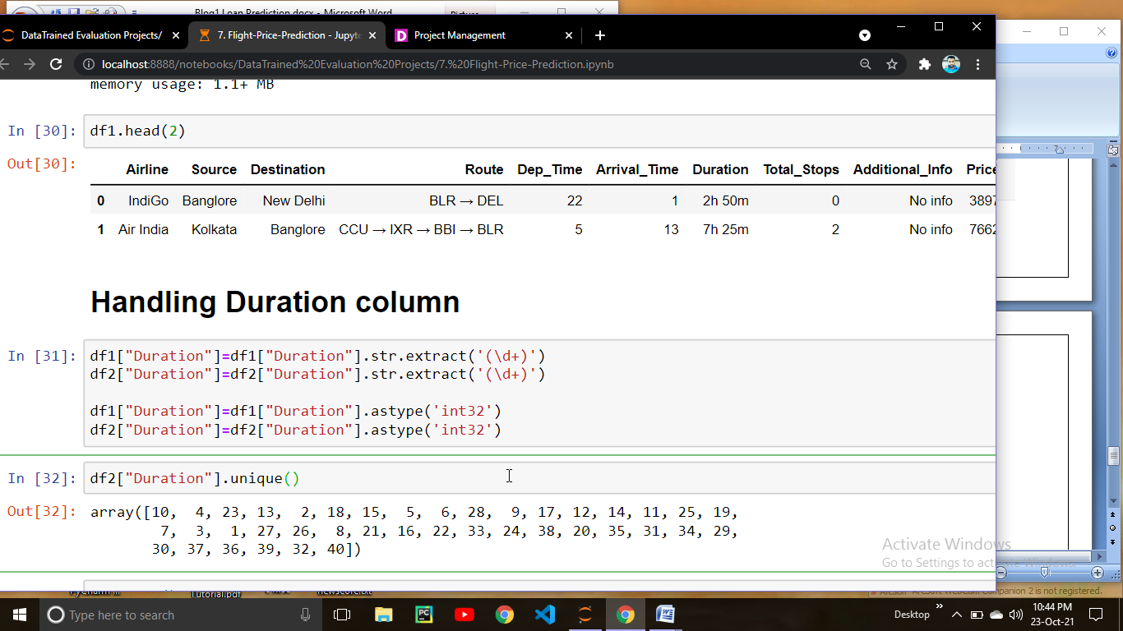

Lets Handel Route Column

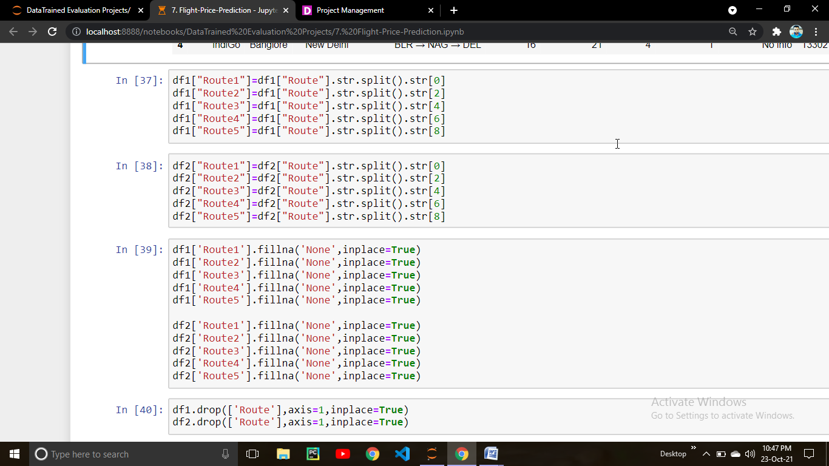

This is how Weed Route column

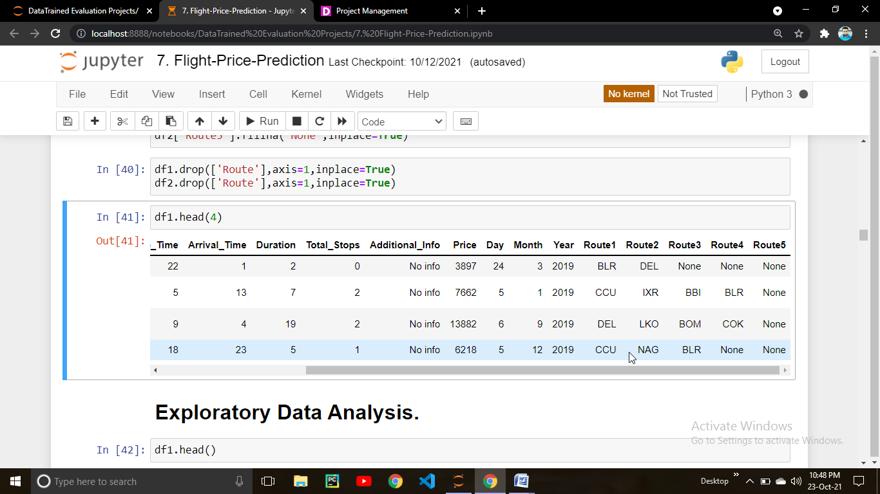

# Data Visualization:

# 

# From the above count plot we can observed that Jet airways has the maximum flights in the data after that indigo comes.

# Lets check from where the maximum flights departed.

# 

# From the above count plot we can observed that Delhi is the Airport from where maximum ( about 41%) flights has departed.

# Lets check the destination

# 

# Here we can noticed that maximum flights has Cochin as a destination airport.

# Lets check the stops of flights

# 

53 % of flights take only one stop before arriving at the destination.

33 % of flights are non stop flights.

12 % of flights take two stop before arriving at the destination.

only 0.41 % of flights take 3 stop and .009 % takes 4 stop.

Lets check at what time is the maximum flight scheduled.

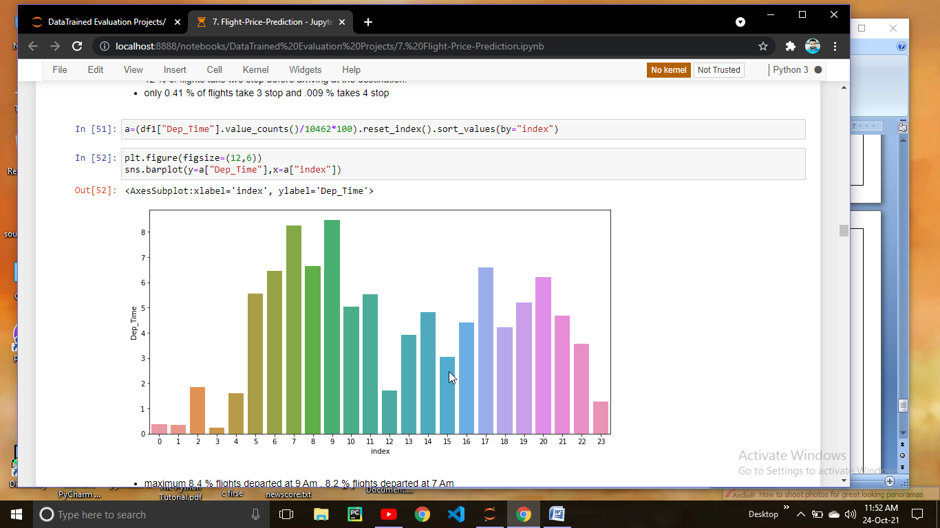

We can observed that maximum 8.4 % flights departed at 9 Am , 8.2 % flights departed at 7 Am.

Lets check wheather number of stops impacting the flight price.

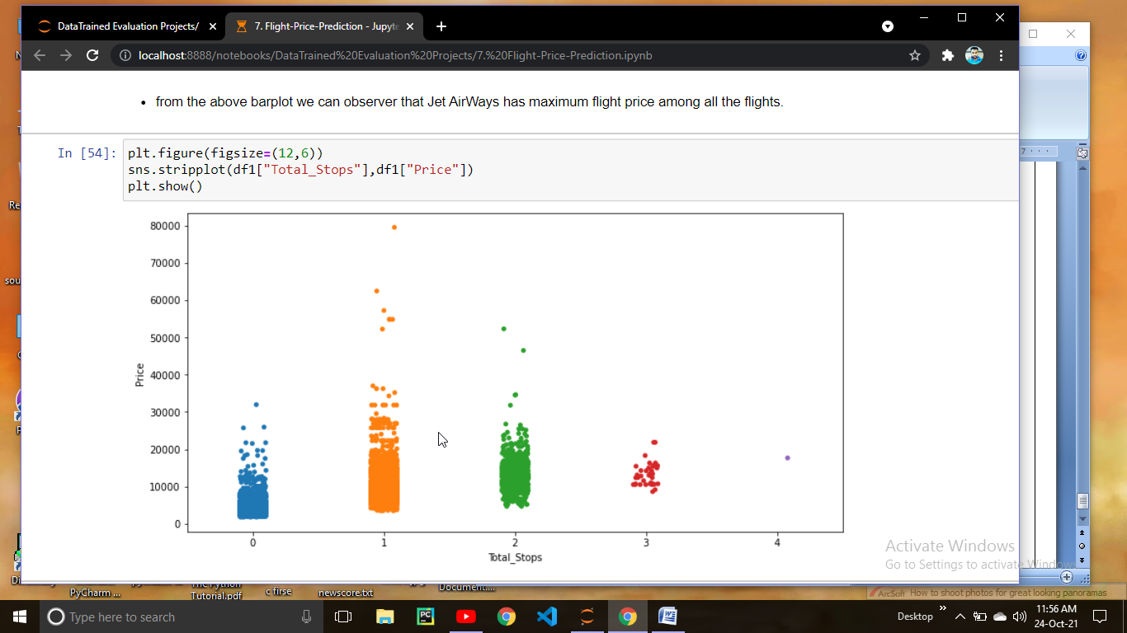

From the above strip plot we can see that maximum flight take one stop before reaching to the destination and price is maximum for the flight who takes one stop it seems to be around 79000 approx.

The maximum price for the flights who have no stop is around 35 k

The maximum price for the flights who takes 2 stop is around 55 k and the maximum price for the flights who have 3 stop is around 25 k

Lets check which airline has the maximum price

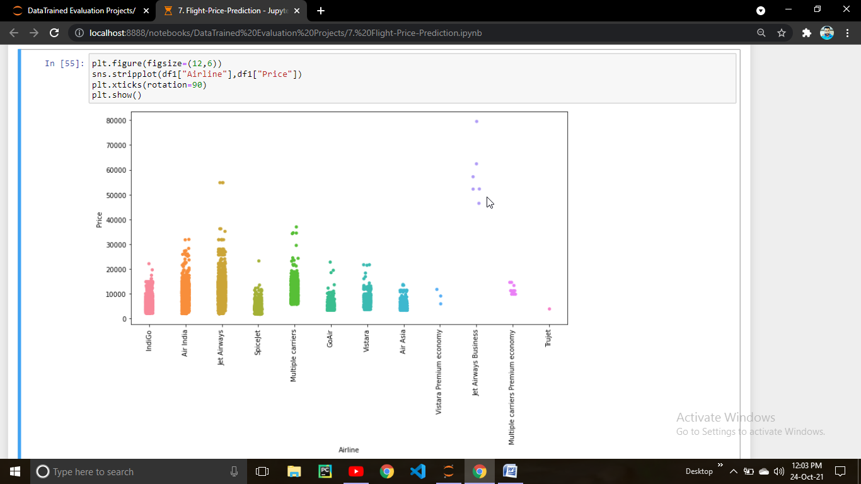

From the above strip plot we can clearly observed that :-

* Maximum price of indigo is around 25 k
* Maximum price of Air India is around 33 k
* Maximum price of Jet AirWays is around 55 k
* Maximum price of Spice Jet,Go Air & Vistara is around 25 k
* Maximum price of Air Asia is around 20 k
* Maximum price of Jet AirWays Bussiness is around 80 k

Lets check wheather the departure time impacting the price

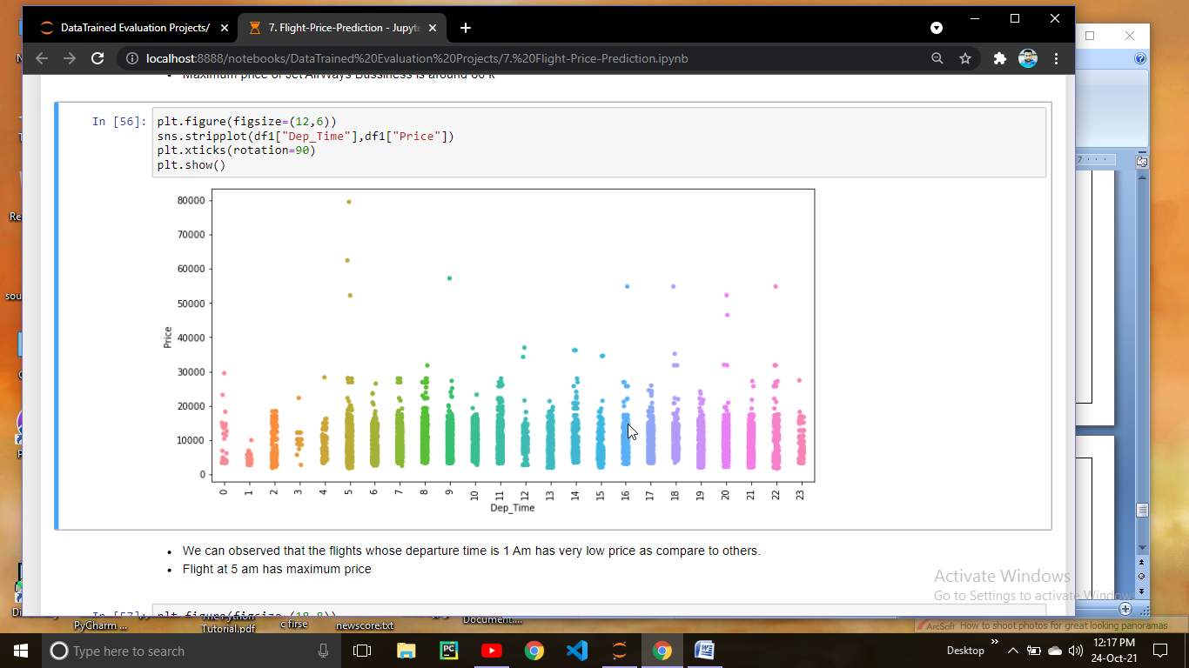We can observed that the flights whose departure time is 1 Am has very low price as compare to others. Flight at 5 am has maximum price.

Lets check the correlation:

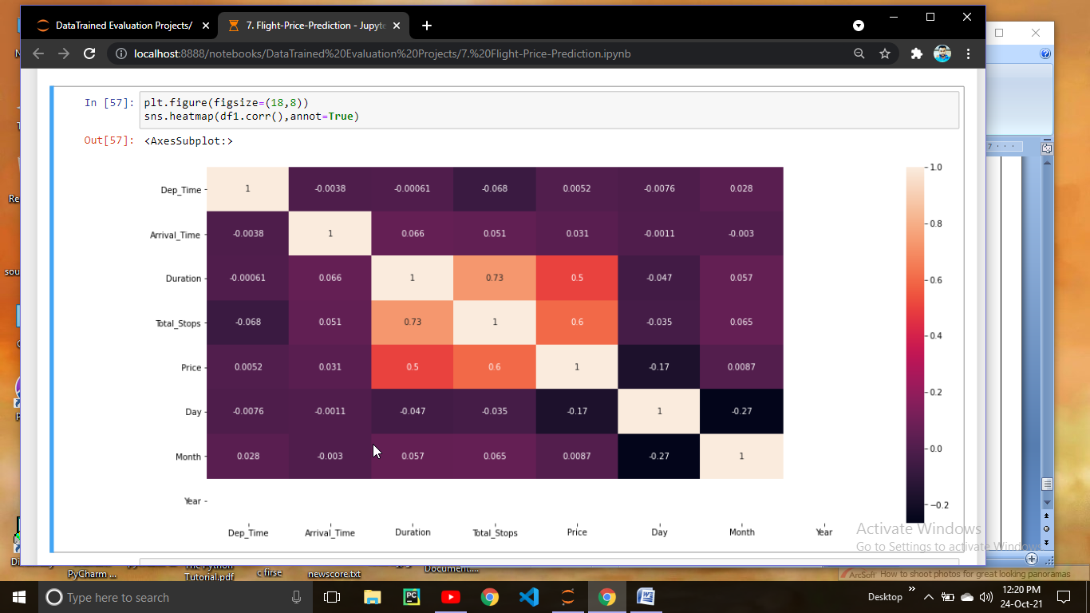

Duration & Total stops are more than 50 % positive correlated to price and Duration & Total Stops are .73 % multicolinear to each other.

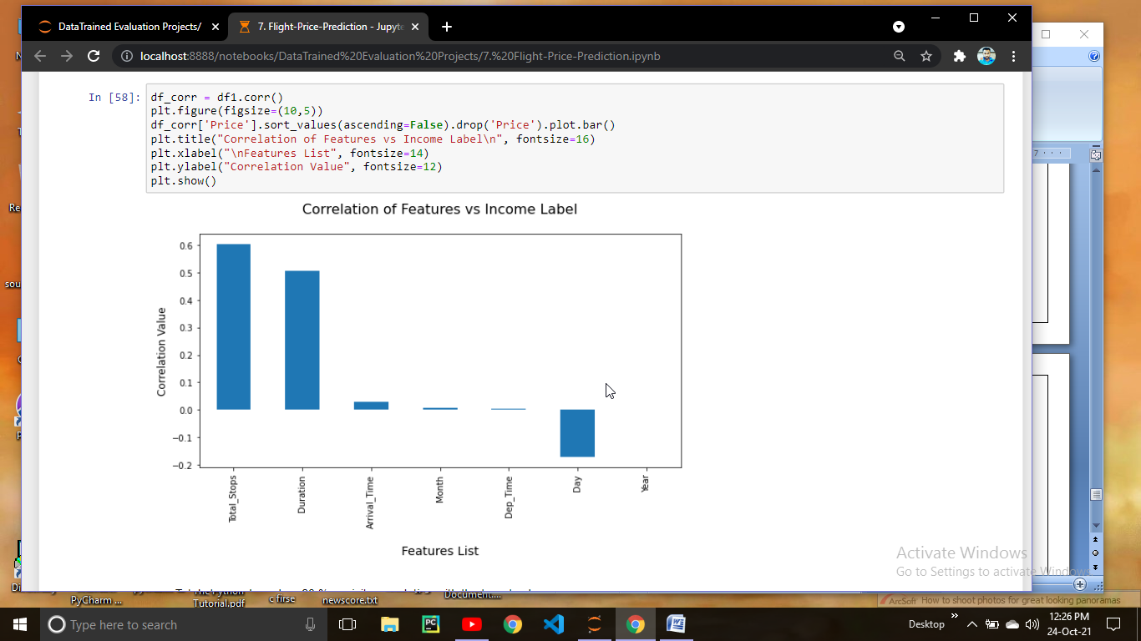

Lets drop the Year Column because this column is not showing any Positive or negative correlation.

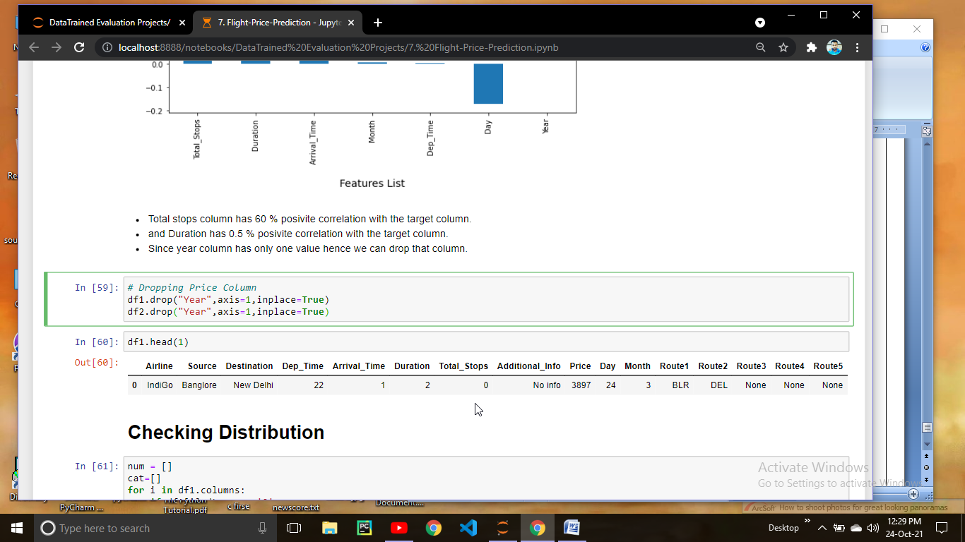

Lets check the distribution of data,before that lets saperate the numerical variables and categorical variables

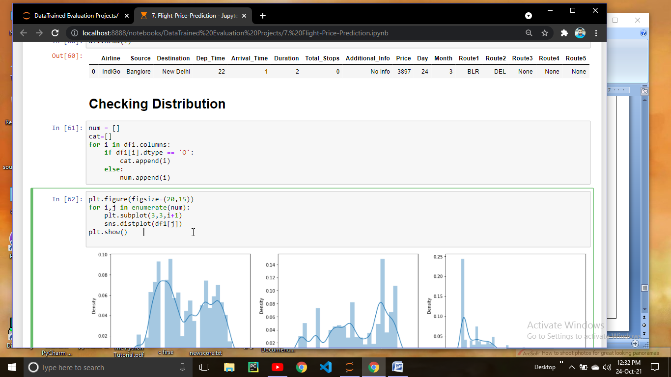

Lets Check the Distribution now.

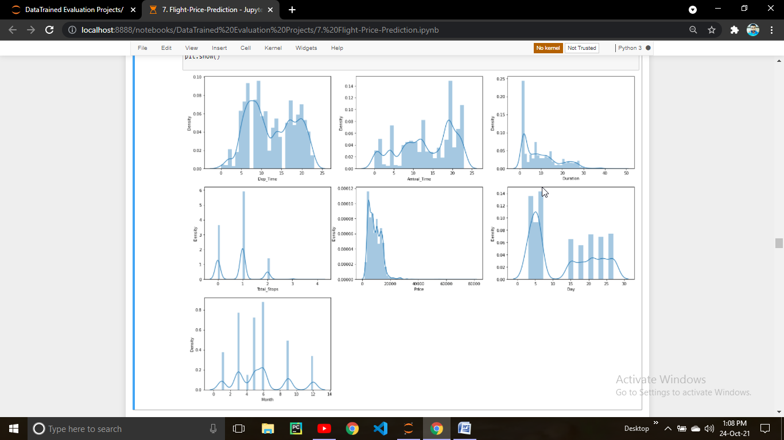

Dep_Time looks normally distributed , Arrival_Time looks left skewed Duration looks right skewed. We have to transform these columns before that lets check the Outliers.

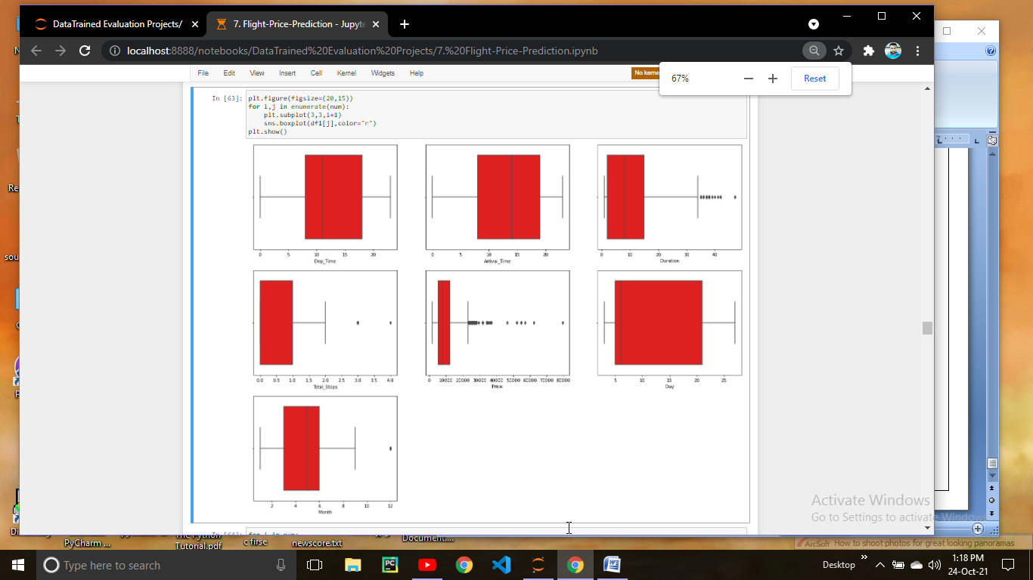

Looks like our data has some outliers so we have to remove them.

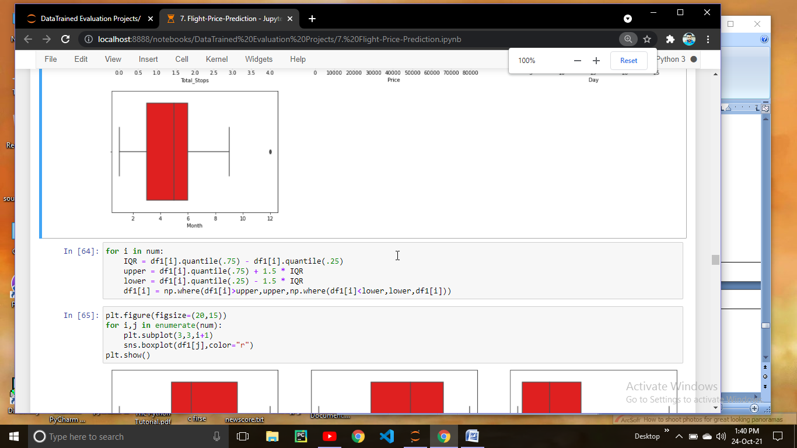

Here we applied IQR method to remove outliers.

**Lets Import important sklearn libraries**

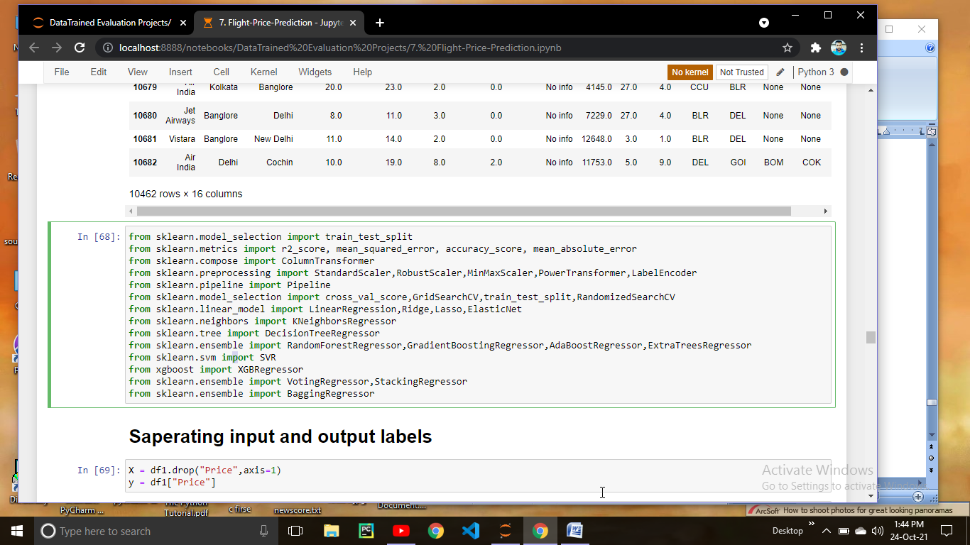

Lets Saperate the data into input Features and output label.

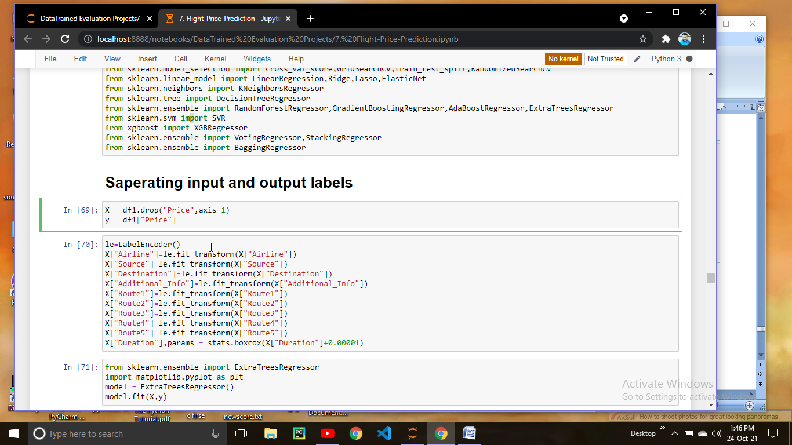

Now we have to encode the categorical variables for that we are going to use LabelEncoder.

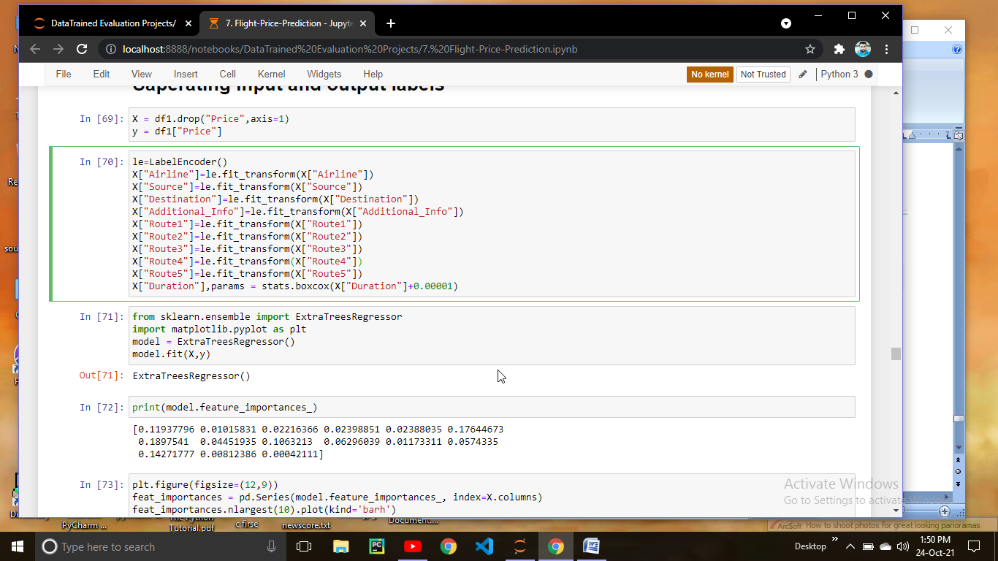

We encode the categorical variables and perform the boxcox transform on Duration column.

**Feature Selection**

Selecting the features using the ExtraTreeRegressor.

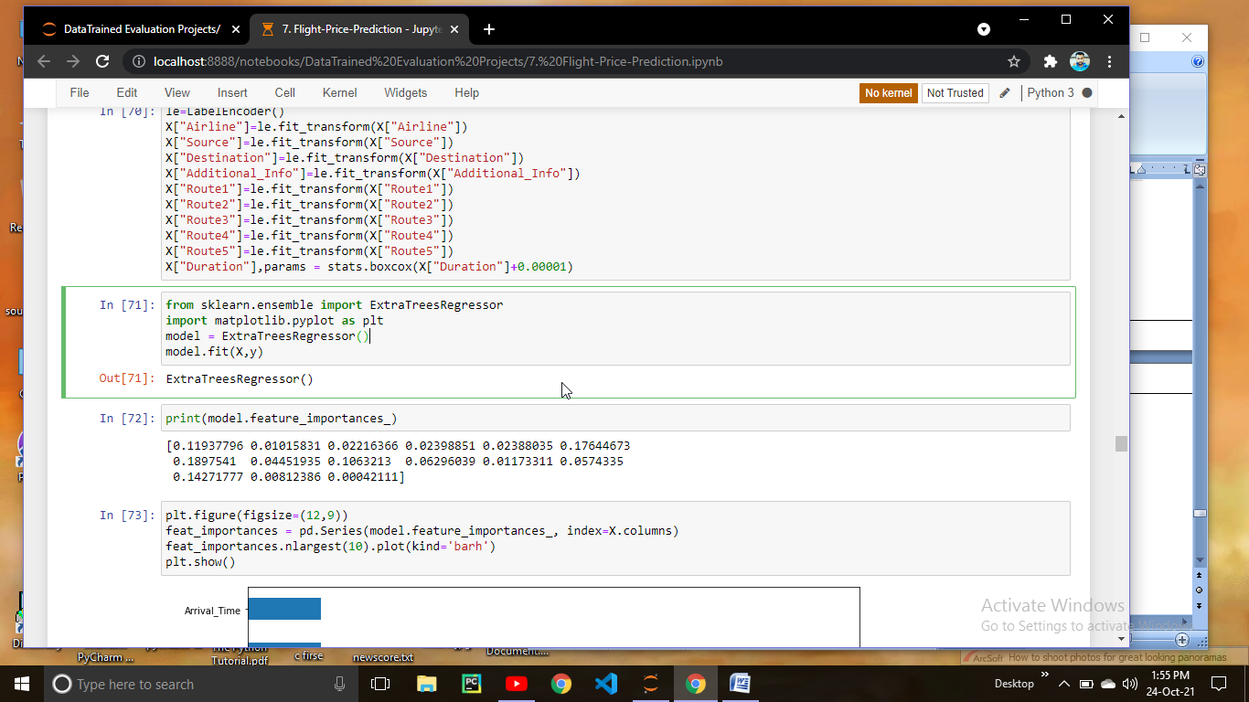

Lets plot the top 10 features from all the features.

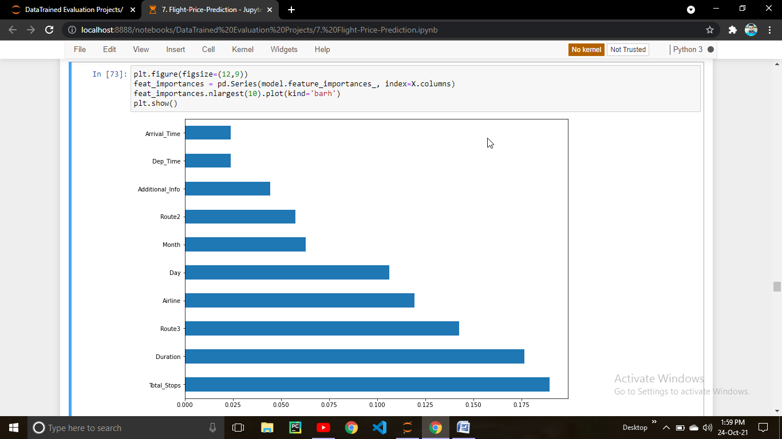

These are the important features selected by the model

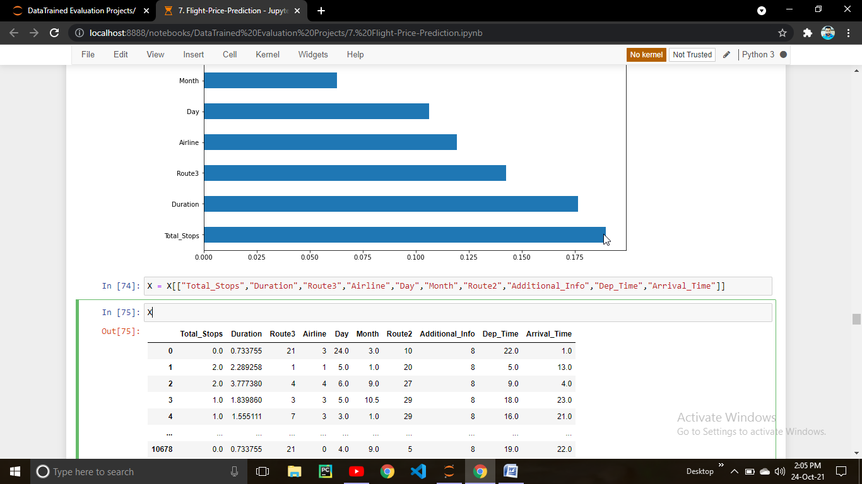

Lets Create a function to check the model Performance

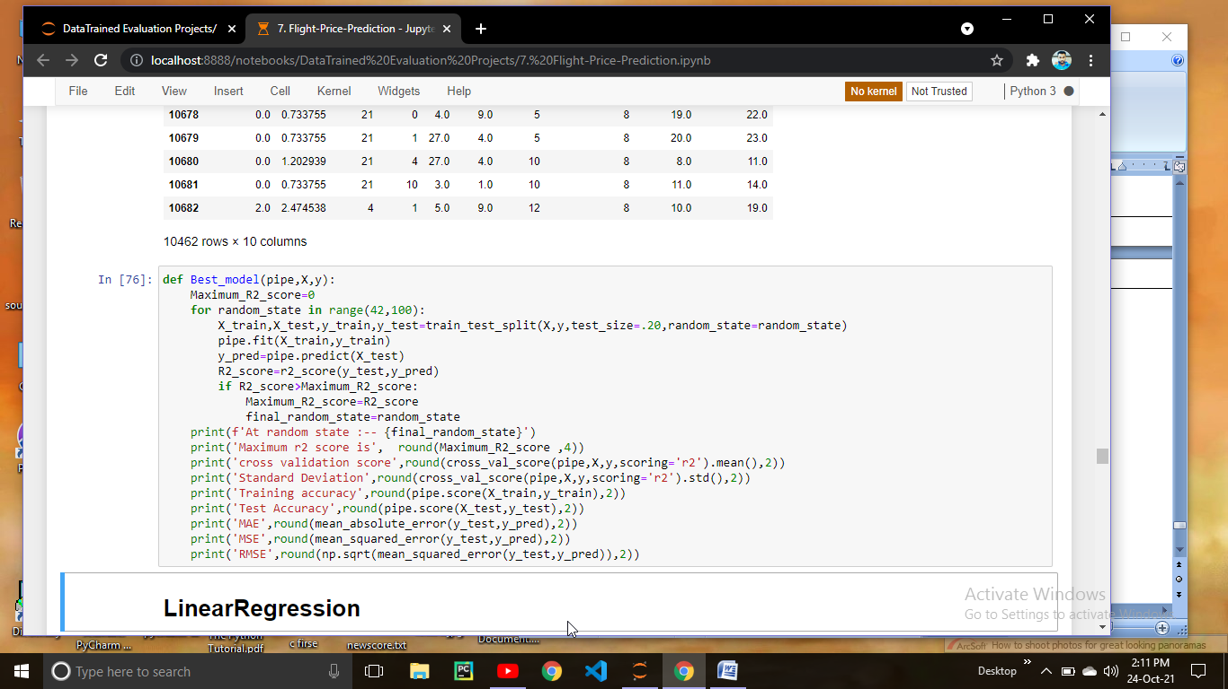

Lets Check the model

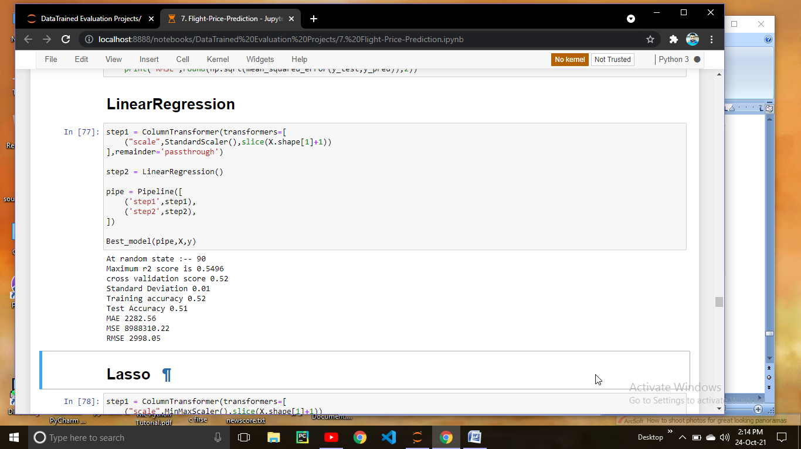

Here what we did is create a pipeline in which standard scaling is performed on our data then model is train in second step.

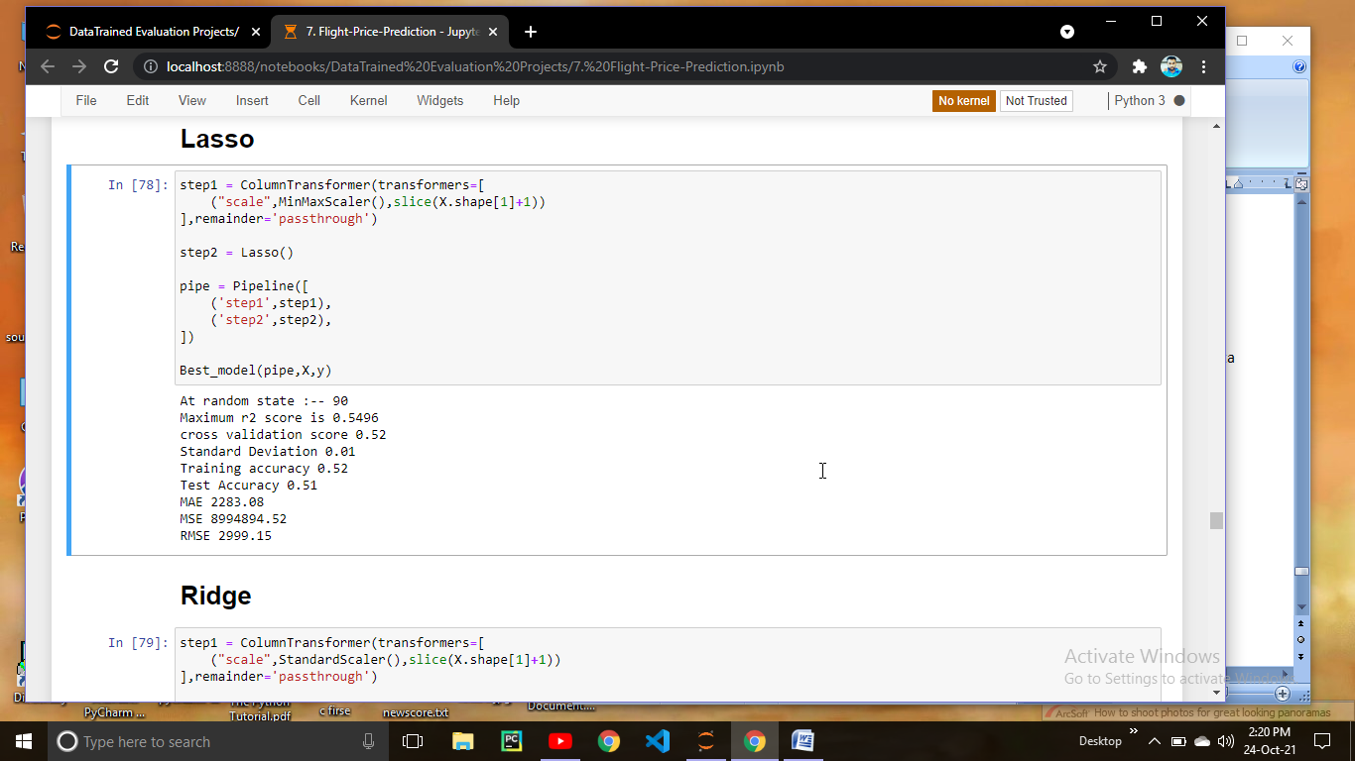

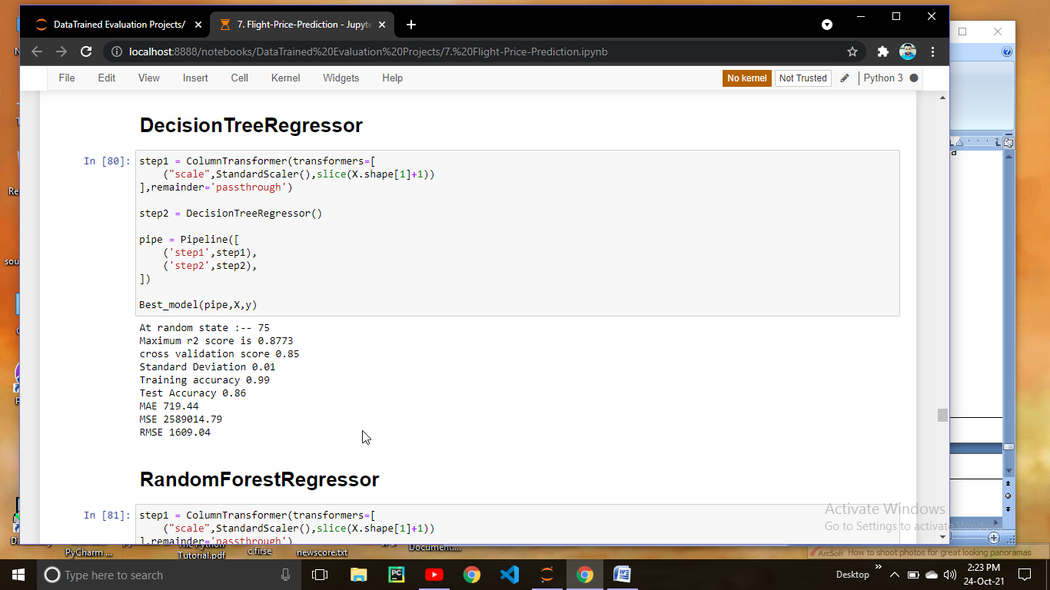

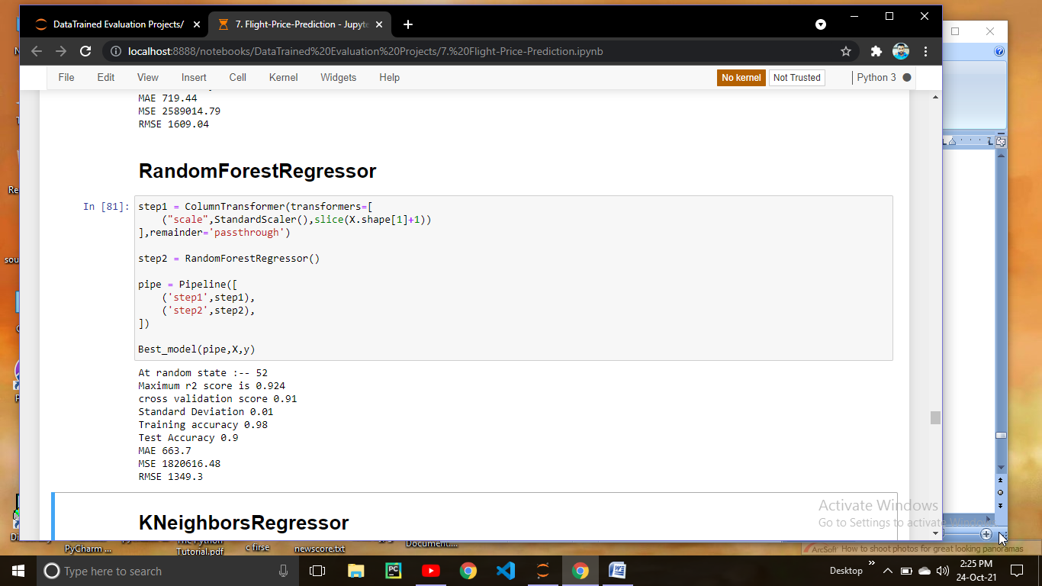 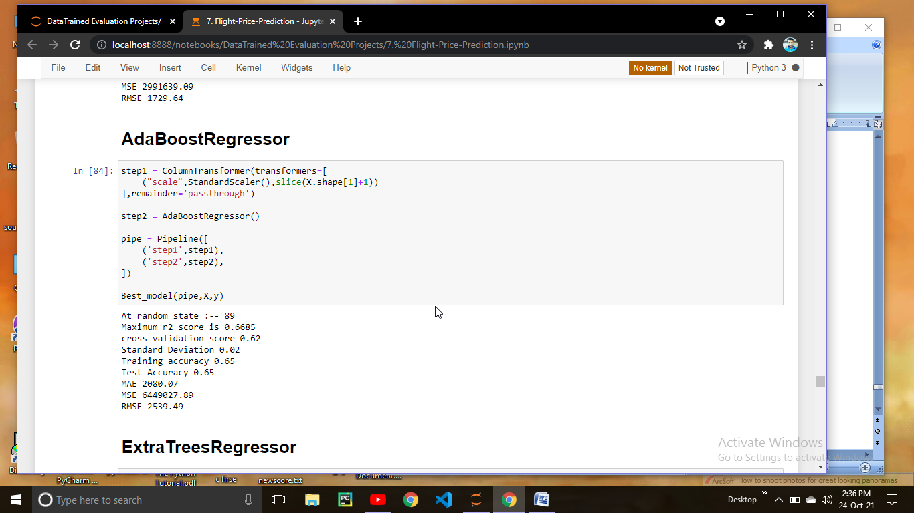

Here we can observed that among all the model, at random state 52, random forest regressor is the best performing because it gives the maximum r2 score along with the cross validation.

Let’s tune the parameter of Random Forest Regressor

**HyperParameter Tuning**

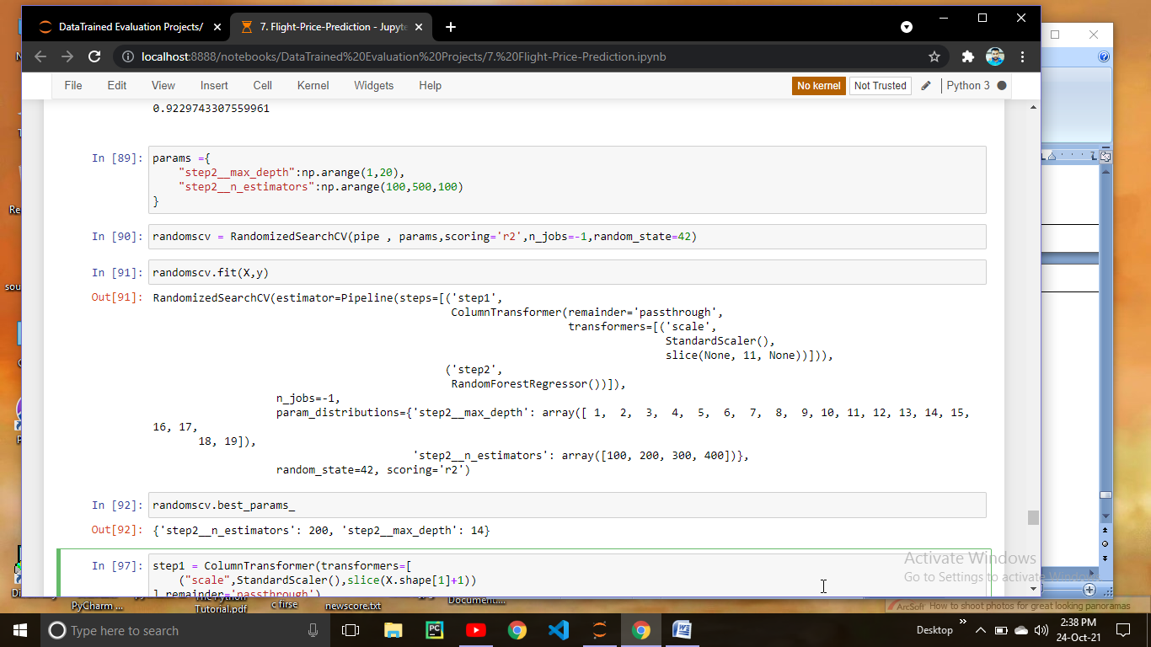

Here we performed the randomized search cv to chech the best parameters for randon forest regressor

Let’s put these parameters in randomforest regressor.

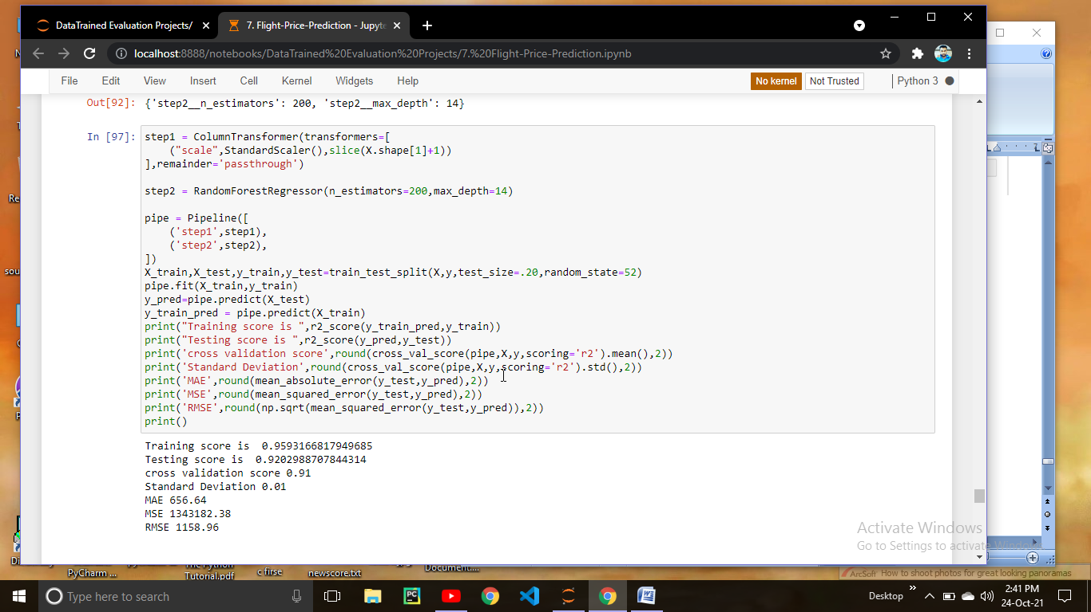

We are getting 92 % r2 score which is pretty much good and cross validation is also 91 which means our model is performing well. so we are going to save the mode

**Saving the model**

To save the model we are using the pickle method

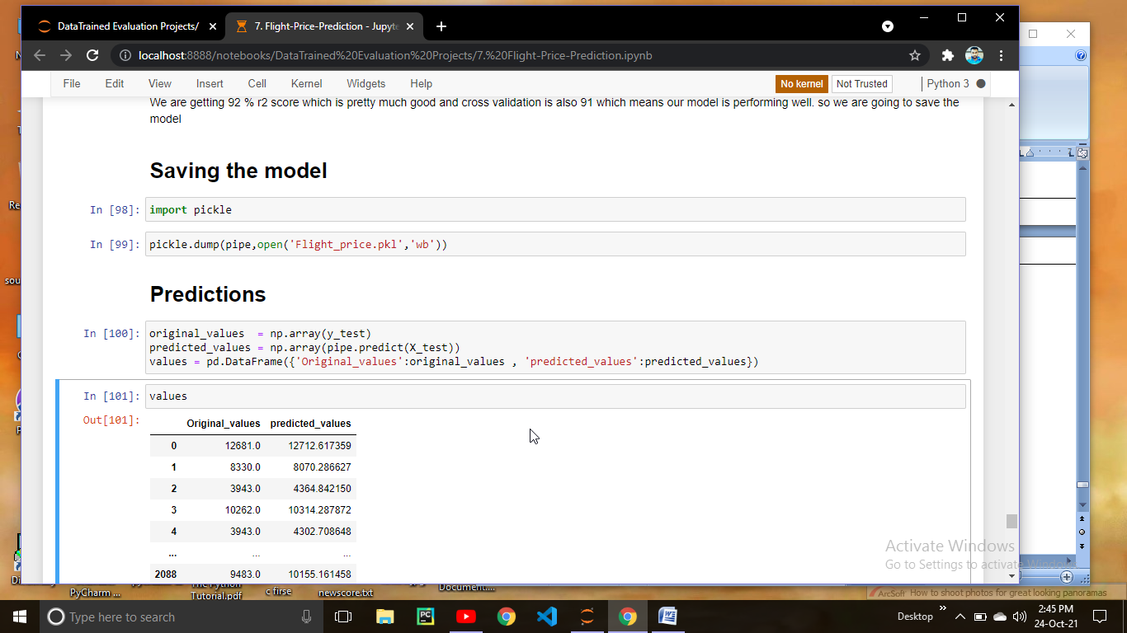

**Let’s Check the predictions.**



Here we can observed that our model is predicting really well. The difference between original price and Predicted price is very low.

Now we have a testing set so we have to test the model on that data also.

Before predicting the test data we have to do all the preprocessing steps that we performed on training data

**Predictions on testing data**

